COME CELEBRATE INTERNATIONAL DEMOCRACY DAY AT THE GRAND LAKE THEATER SEPTEMBER 16 7:15PM
A BENEFIT FOR ON THE GROUND DEMOCRACY GROUPS
Indivisible East Bay, Seed the Vote, Movement Voter Project, Flip the Vote

Viktor Orban was defeated after 16 years of autocratic rule.
The formula could defeat Trump too.
M. Gessen, NYT

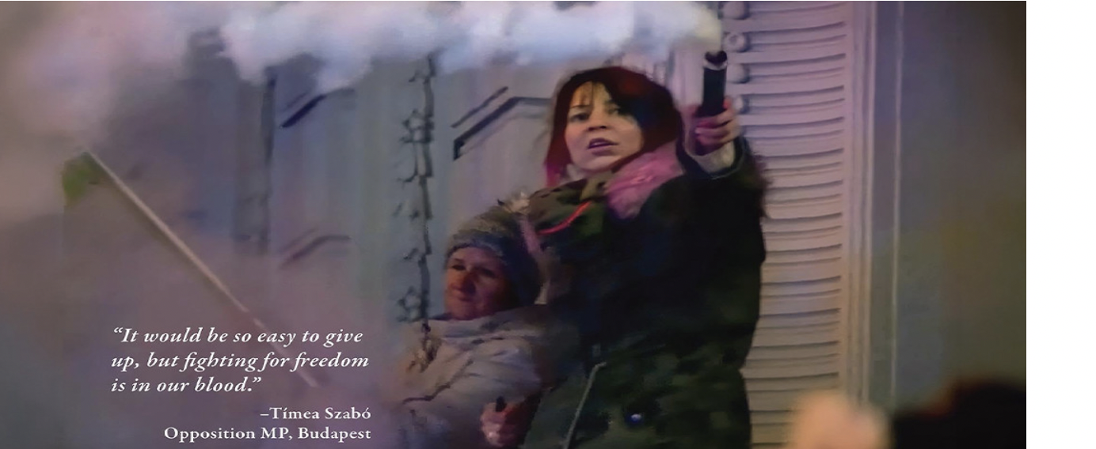

Democracy Noir: A New Dawn
Trailer: https://www.youtube.com/watch?v=xr0tneWNC1U
Ticket Purchase: http://73279.formovietickets.com:2235/T.ASP?WCI=BT&RtsPurchaseId=b83930ae-173a-4524-b55d-9a9089b1c5fb&Page=PickTickets&SHOWID=75355

A film by Academy Award Nominee and Emmy Winning Director Connie Field
and Producer Sigrid Dyekjaer

Democracy Noir: A New Dawn, tells the inspiring story of resistance in Hungary to Viktor Orban’s regime and of his stunning defeat. Our film tells this story through the brave activism of its three subjects, - opposition politician Timea Szabo, journalist Babett Oroszi, and nurse Nikoletta (Niko) Natal.

The film provides a sweeping account of how Viktor Orbán used a free and democratic election to install authoritarian rule in Hungary, enjoying widespread approval from Hungarian nationalists as well as global conservatives inclined to his illiberal views. He changed the constitution, took over the courts, dismantled the rule of law, and took over the media. Revered by Donald Trump and the Heritage Foundation, Orban’s influence helped shape Project 2025 and the current policies of the Republican Party.

On April 12, 2026 Peter Magyar’s party Tisza came to power in Hungary after 16 years of the autocratic rule of Viktor Orban. The triumph was unique in our era of democratic backsliding — and it holds clear lessons for the United States.

In his campaign Peter Magyar enumerated the ways in which Orban had damaged Hungary: a stalled economy, inadequate health care, an atmosphere of hatred and fear. Orban had “stolen from the common good of the Hungarian nation — from the pockets of the Hungarian people” He called Orban’s government a mafia state — a fundamentally criminal enterprise.

His win revealed that in-person politics can be a powerful antidote to media fearmongering. 80% of the Hungarian population voted, the highest ever! Young people drove the campaign, 90% voting for Magyar. Magyar did not create his political machine from scratch. A panoply of grass-roots protest movements joined ordinary Hungarians to end the Orban era.

